**COLLEGE ADMISSION FORM – BOTTOM-UP APPROACH**

**Submitted to Prof Ashok Harnal Submitted by Group 13**

Dipu Kumar 025013

Jatin Malhotra – 025016

Karthick P M – 025053

**INTRODUCTION**:

We have selected College admission form for Bottom-up approach to database designing. We collected raw data for the admission form and carried normalization up to 3NF.

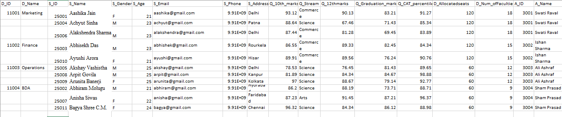

**FIRST NORMAL FORM**

According to the first normal form, there should be no nested tables for all groups of elements. to make the table satisfy the first normal form the group was removed by giving the sets the values for their missing attributes. after the first normalization, the following table was obtained:

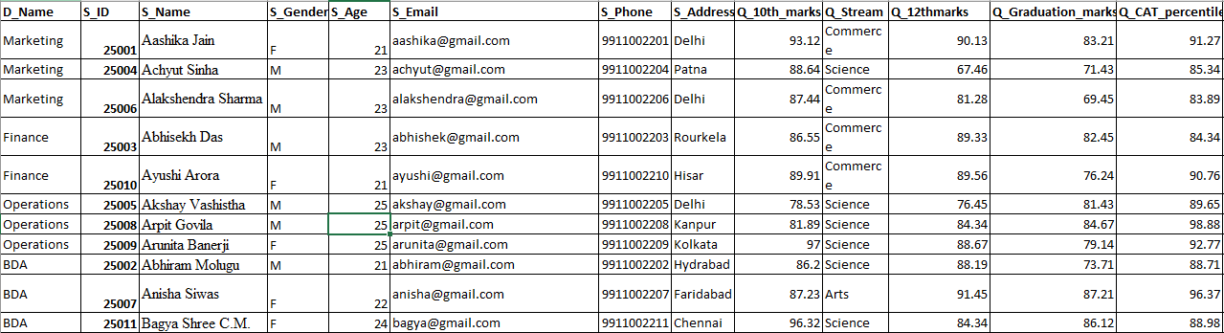

**Composite Primary keys – S_ID and D_ID (Student ID and Department ID)**

**SECOND NORMAL FORM:**

The second normal form says there should be no dependencies on a part of the composite key if any such part exists in the table they need to be separated along with that primary key.

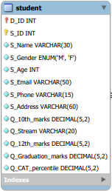 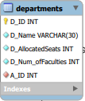 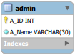

**THIRD NORMAL FORM:**

The third normal form is about no dependencies on non-key attributes. In our table, there are no dependencies on non-key attributes.

**ERD Diagram:**

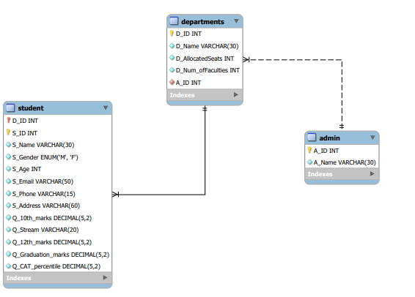

**ASSUMPTIONS**:

1. There are only four departments such as marketing, finance, operations and BDA

2. Each student can get only one department.

3. There will be one unique admin for each and every department.

4. All students must get minimum 60 % throughout 10th, 12th and graduation marks

5. All students must have phone number and email address.

6. CAT percentile should be minimum 80% for all students.

**DDL COMMANDS FOR TABLES:**

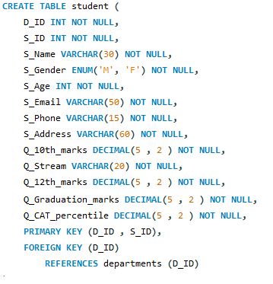

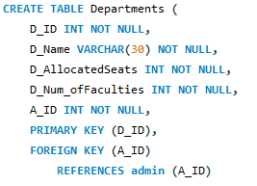

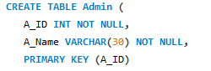

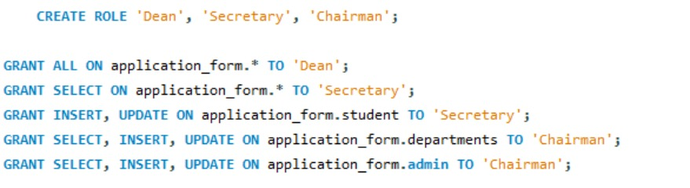

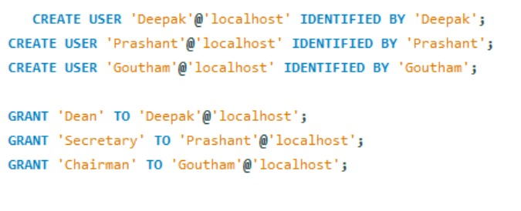

**CONCLUSION**:

The college admission database stores the information of students who got admission to the college and details of the allotted courses. We granted all permissions to view and edit the database to the Dean of the college, student details to the secretary, and Department & admin details to chairman of the college. We created three users and granted access to them. We are able to extract desired information from the college admission database.